
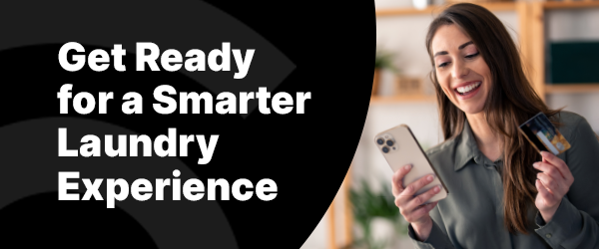

We’re excited to announce that your laundry room is being upgraded! Soon, you’ll enjoy a smarter, more convenient way to do laundry with the One Tap Away Mobile app. The machines will show a vend price, but will run free.
Download the One Tap Away Mobile app for free on iOS or Android.

You’ll Love One Tap Away:
- No more coins or cards!
- Check machine availability and receive cycle notifications.
- Access exclusive deals on everyday goods and services through the OTA Marketplace.

Visit our Resource Page for more information and access step-by-step instructions to prepare for the upgrade.
If you have any questions or need assistance, please contact Res Life or call 844-272-9675.
Download the App Now

Best regards,
The CSC ServiceWorks Team

